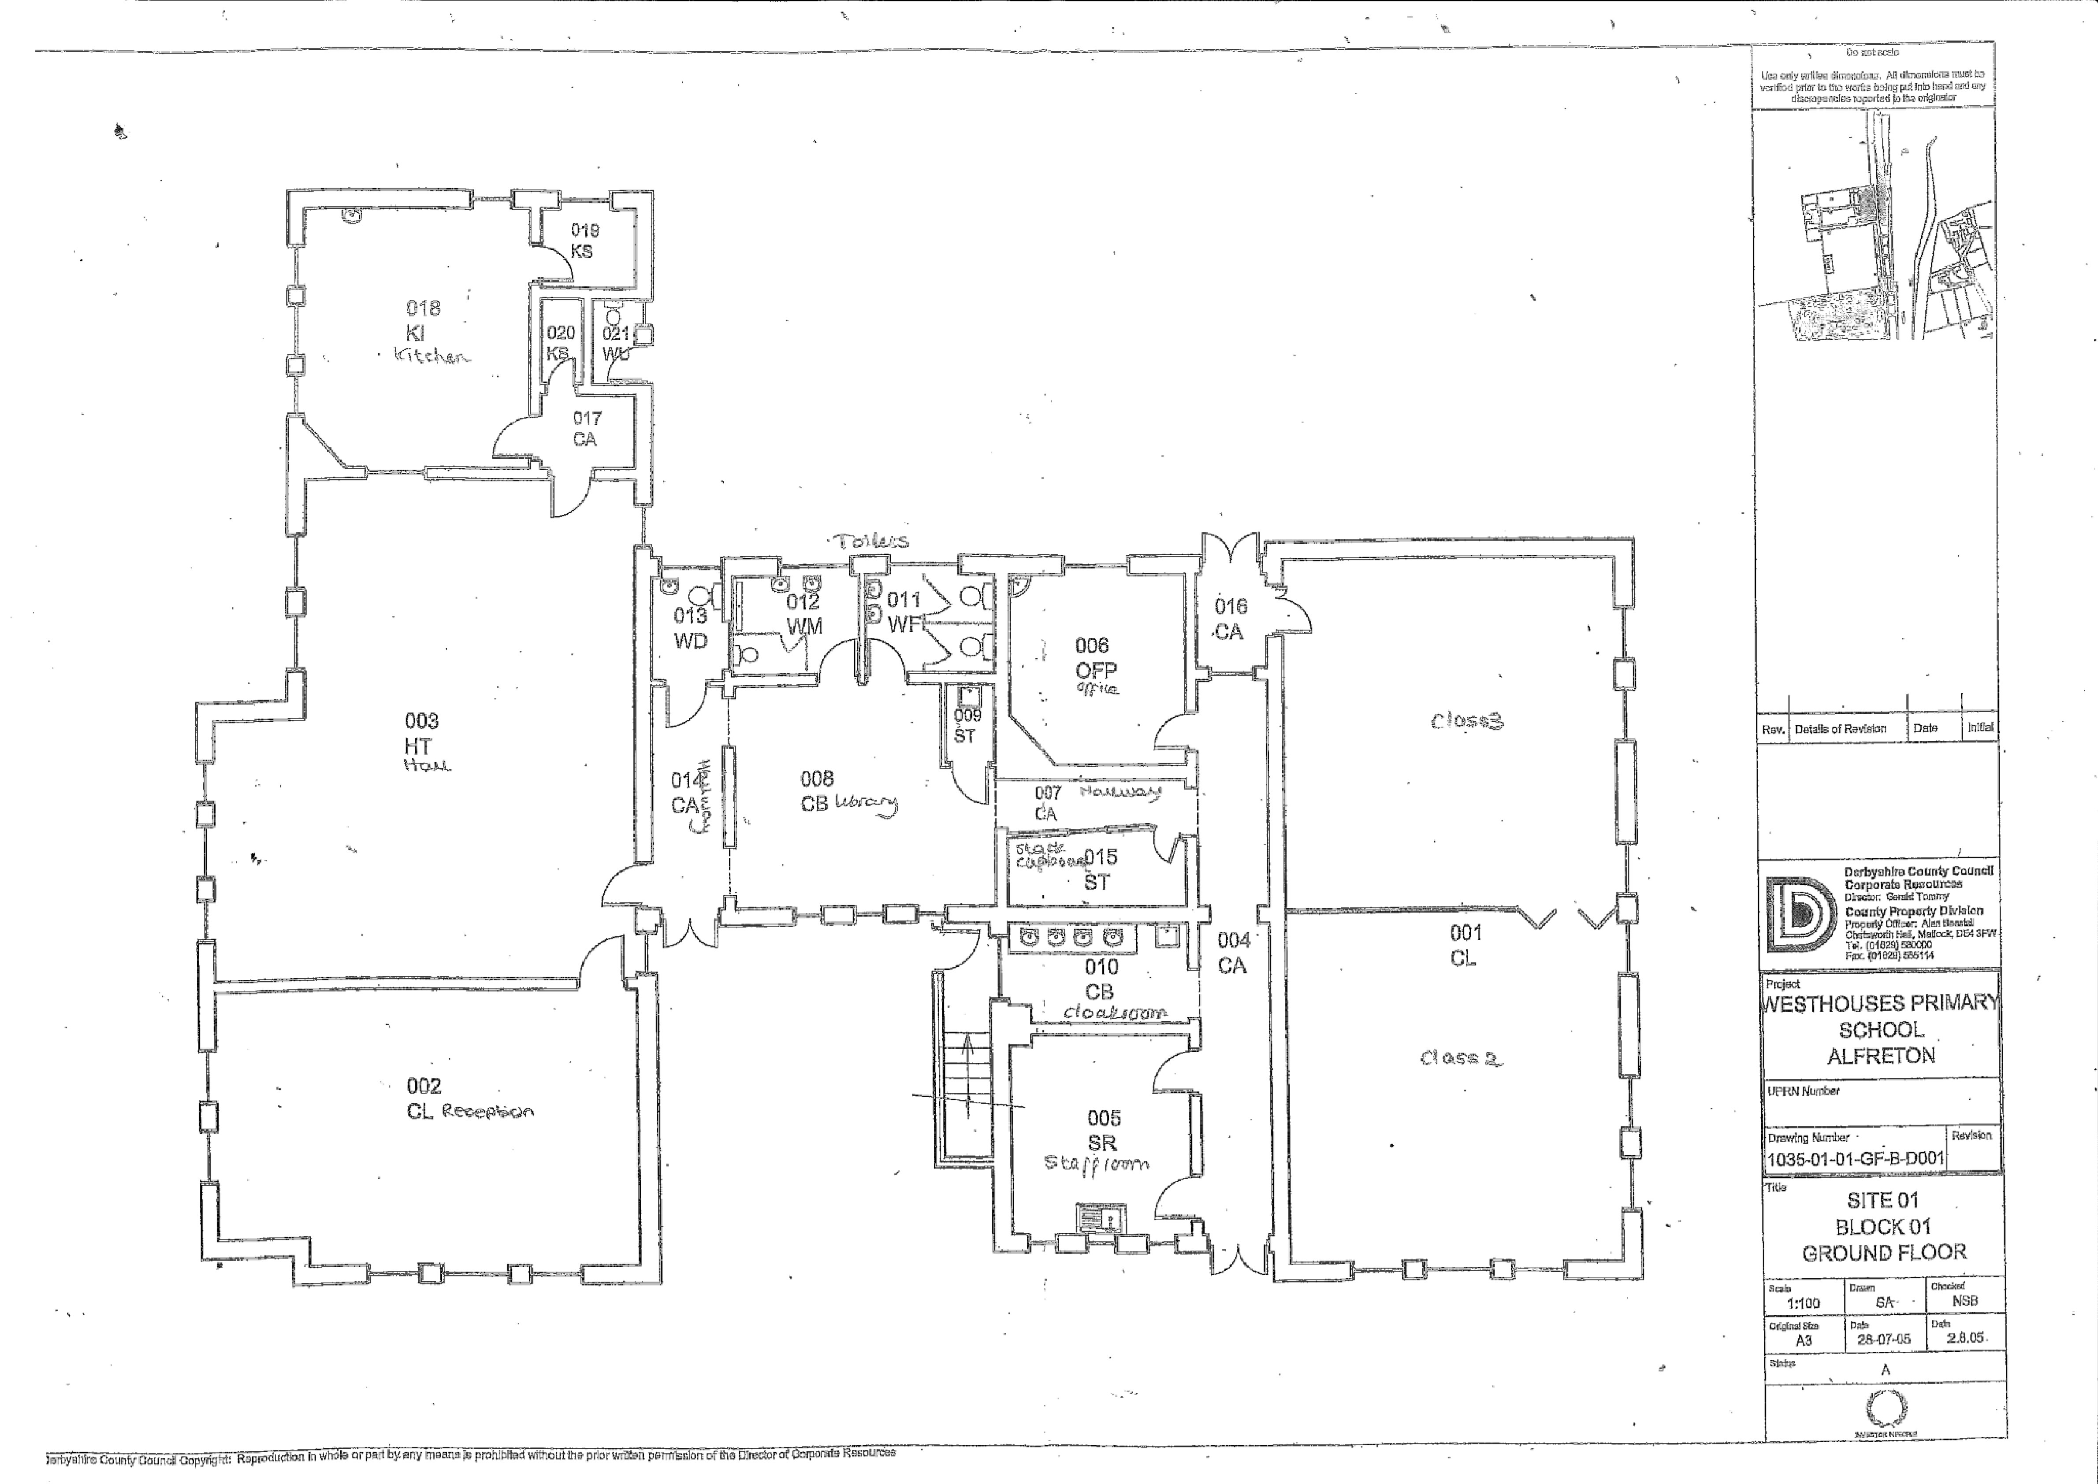

“Calm.”

“Roomy”

“Positive.”

“Mixed emotions because I have only been here 3 weeks.”

“Comfortable and happy.”

“Like home.”

“Like a home.”

“Relax – I feel calm and relaxed in the library because I know nothing can stress me out when I’m here. It’s like the church of the school.”

“I enjoy the painting and lights in the hallway.”

“Squished”

“I feel reluctant to go in the cloakroom because it is cramped.”

“Safe because this is where the IPADS are and I am an IPAD monitor.”

“Unsafe – I feel unsafe in the toilets because at dinner they are very cramped”

“Small”

“Noisy – they scream a lot”

“Nostalgic”

“Safe and sound”

“Annoying because we are sat Knee to Knee”

“Unsure – haven’t been in here”

“Mr Nutt is friendly”