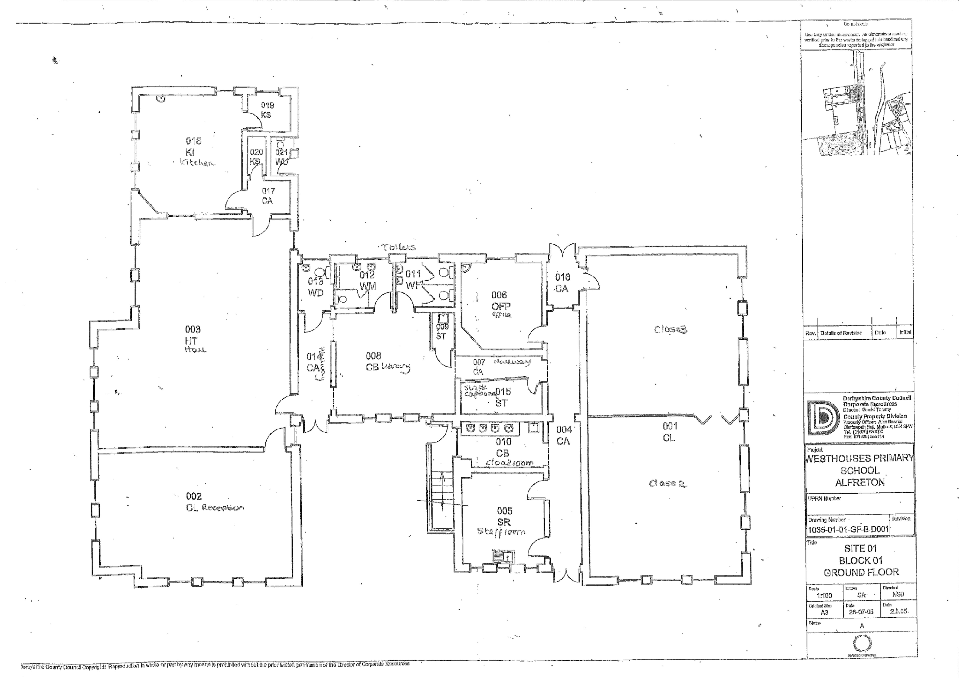

“I don’t feel safe in here because there are children”

“I feel safe when I play”

“I feel safe because it’s my class”

“I feel safe because my brother is in here”

“I feel safe on the friendship bench”

“I don’t feel safe because it’s not my class”

“It’s too busy”

“I feel safe in here because nobody can get in the cubicles”

“I feel safe because Mrs Whitby is in here”

“Books might fall on you”

“I feel safe in here because its calm and peaceful”

“I feel safe in here because there are young children”

“I feel safe here because my friends are here”

“I don’t feel safe in the kitchen because of fire”