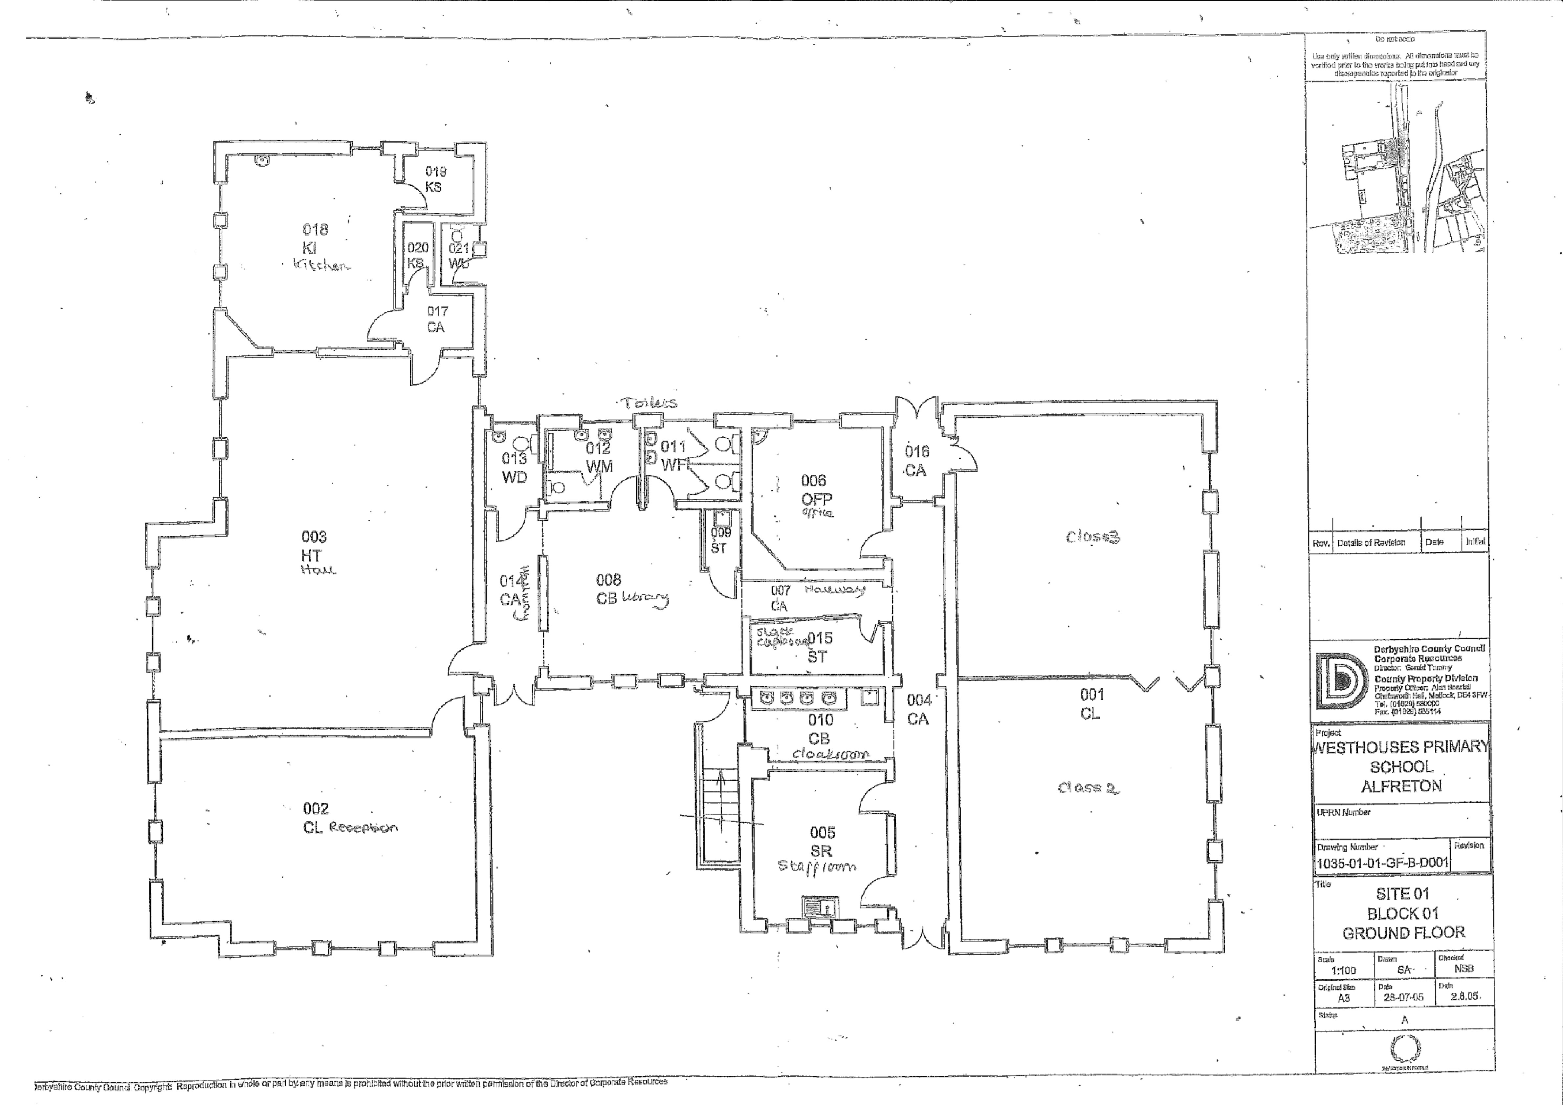

62% places that could be improved

20% where unsure how they felt

15% felt safe and happy

0% places that could be improved

11% where unsure how they felt

88% felt happy and safe

65% places that could be improved

0% where unsure how they felt

45% felt safe and happy

16% places that could be improved

27% where unsure how they felt

55% felt safe and happy

15% places that could be improved

31% where unsure how they felt

56% felt safe and happy

3% places that could be improved

25% where unsure how they felt

71% felt safe and happy

3% places that could be improved

4% where unsure how they felt

93% felt safe and happy

Playground

Hallway

Stock cupboard

Class 2 (Philosophers)

Class 3 (Trailblazers)

Office

27% places that could be improved

4% where unsure how they felt

68% felt safe and happy

Cloakroom

Staff room

Toilets

31% places that could be improved

23% where unsure how they felt

45% felt safe and happy

Library

4% places that could be improved

7% where unsure how they felt

87% felt safe and happy

7% places that could be improved

21% where unsure how they felt

72% felt safe and happy

Reception class

9% places that could be improved

3% where unsure how they felt

87% felt safe and happy

The Hall/Class 1 (Explorers)

The Kitchen

46% places that could be improved

15% where unsure how they felt

37% felt safe and happy