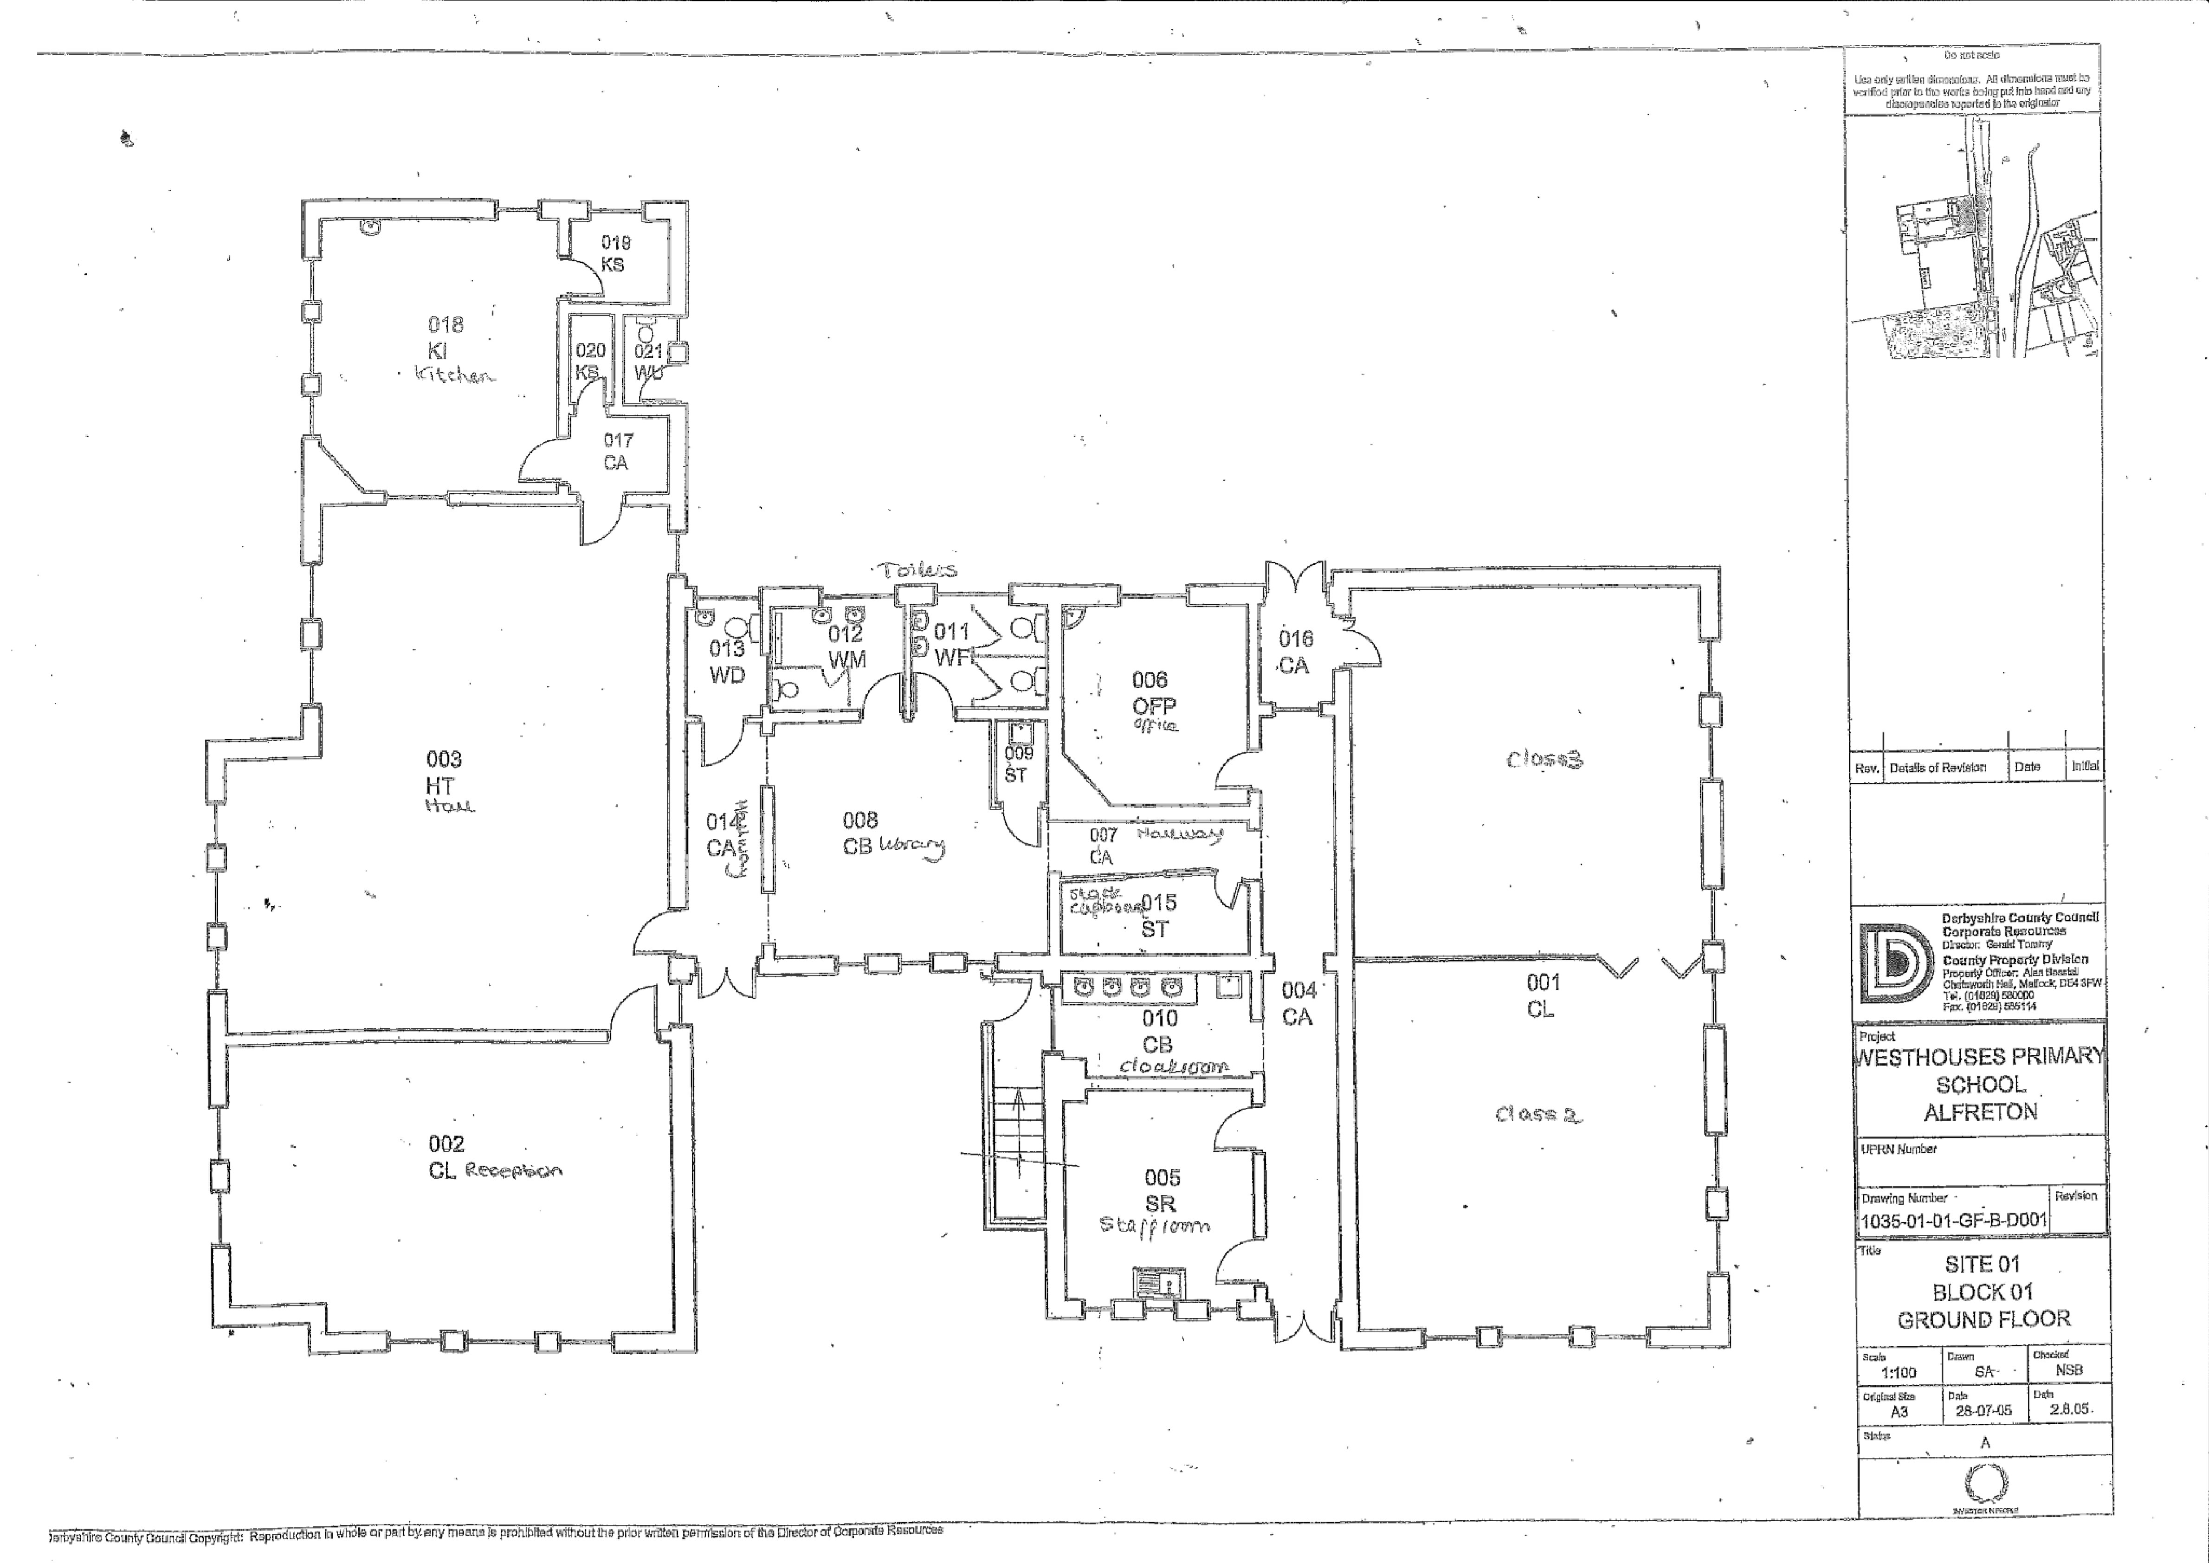

“Fun and exciting we get to play with everyone”

“Good, makes us happy because Mrs Newton and Mrs Whitby are teachers in there”

“Small and untidy”

“Too squashed”

“Lots of fun”

“Scary”

“The office is good because Mrs Whitby is in there”

“Like to eat in and it’s our classroom”

“Worried about equipment”

“Mr Nutt cooks the best food”

“Good but big children are there”

“Frightened of slipping in the hallway”

“Good – hot chocolate”